**Model Parameters:**

* Max token
* Temperature
* Frequency Penalty
* Presence Penalty

**Prompt Engineering**

<https://platform.openai.com/docs/guides/prompt-engineering>

**Prompt Examples**

<https://platform.openai.com/examples>

**Six Strategies for Getting better results**

* Write clear instructions
* ​​<https://platform.openai.com/docs/guides/prompt-engineering/strategy-write-clear-instructions>
* Provide reference text
* Split complex task to simpler subtasks
* Give the model time to think
* User external tools
* Test Change systematically

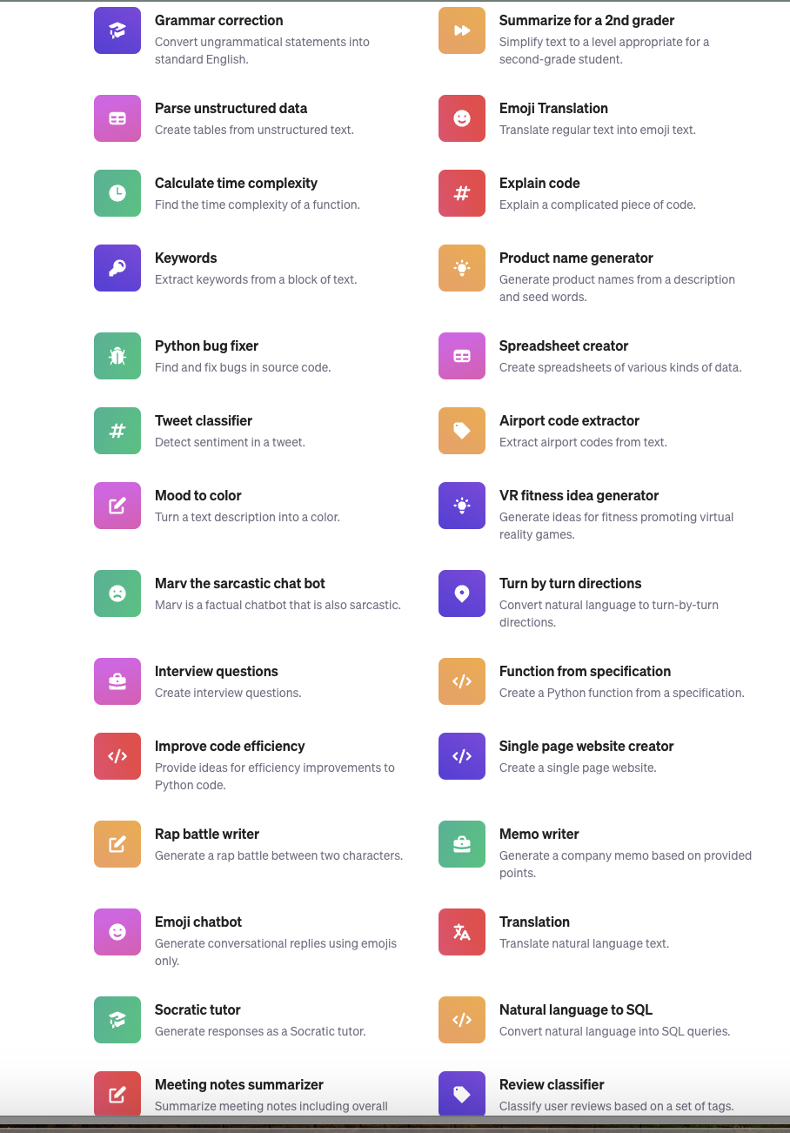

Git repo for learning:

<https://github.com/ROBROICH/intro-to-intelligent-apps/>

**Playground to API:**

from openai import OpenAI

client = OpenAI()

response = client.chat.completions.create(

model="gpt-3.5-turbo",

messages=[

{"role": "system", "content": "You are a helpful assistant."},

{"role": "user", "content": "Who won the world series in 2020?"},

{"role": "assistant", "content": "The Los Angeles Dodgers won the World Series in 2020."},

{"role": "user", "content": "Where was it played?"}

]

)

API reference document

<https://platform.openai.com/docs/api-reference/chat/create>

**Response:**

{

"choices": [

{

"finish_reason": "stop",

"index": 0,

"message": {

"content": "The 2020 World Series was played in Texas at Globe Life Field in Arlington.",

"role": "assistant"

},

"logprobs": null

}

],

"created": 1677664795,

"id": "chatcmpl-7QyqpwdfhqwajicIEznoc6Q47XAyW",

"model": "gpt-3.5-turbo-0613",

"object": "chat.completion",

"usage": {

"completion_tokens": 17,

"prompt_tokens": 57,

"total_tokens": 74

}

}

<https://platform.openai.com/docs/guides/text-generation/chat-completions-api>

<https://platform.openai.com/docs/guides/text-generation/json-mode>

from openai import OpenAI

client = OpenAI()

response = client.chat.completions.create(

model="gpt-3.5-turbo-0125",

response_format={ "type": "json_object" },

messages=[

{"role": "system", "content": "You are a helpful assistant designed to output JSON."},

{"role": "user", "content": "Who won the world series in 2020?"}

]

)

print(response.choices[0].message.content)

**Deterministic output:**

<https://cookbook.openai.com/examples/reproducible_outputs_with_the_seed_parameter>

**How to count token:**

<https://cookbook.openai.com/examples/how_to_count_tokens_with_tiktoken>

**Parameters Details:**

<https://platform.openai.com/docs/guides/text-generation/parameter-details>

<https://platform.openai.com/docs/guides/text-generation/faq>

—----

**Vector database**

<https://cookbook.openai.com/examples/vector_databases/readme>

<https://www.mongodb.com/products/platform/atlas-vector-search>